Notes on Lambda-01
Copied the same notes from ChatGPT for more clarity:
AWS Lambda is a serverless compute service from Amazon Web Services (AWS) that lets you run code without provisioning or managing servers.
You simply upload your code, and Lambda:
- Runs it in response to events
- Automatically scales
- Charges you only for the compute time you use

🔹 How AWS Lambda Works
- You write your function (Node.js, Python, Java, Go, etc.)
- You upload it to AWS Lambda
- You configure a trigger (an event source)
- Lambda executes your code when the event occurs
You are billed based on:
- Number of requests
- Duration of execution (milliseconds)
- Memory allocated

🔹 What is “Serverless”?
Serverless does NOT mean no servers.
It means:
- You don’t manage servers
- AWS handles provisioning, scaling, patching, and maintenance

🔹 Common Use Cases of AWS Lambda
1️⃣ Web & API Backends
- Build REST APIs using Amazon API Gateway + Lambda
- Backend for web or mobile applications
- Microservices architecture
Example:
User sends request → API Gateway → Lambda → Database → Response

2️⃣ Real-Time File Processing
Triggered when files are uploaded to Amazon S3.
Examples:
- Image resizing
- Video transcoding
- PDF generation
- Data transformation

3️⃣ Event-Driven Applications
Lambda runs automatically in response to:
- Database updates (DynamoDB Streams)
- Messages in SQS
- SNS notifications
- CloudWatch events

4️⃣ Automation & DevOps Tasks
- Automatically start/stop EC2 instances
- Log monitoring
- Scheduled tasks (cron jobs)
- Infrastructure automation

🔹 Advantages of AWS Lambda
✅ No server management
✅ Automatic scaling
✅ Pay only for usage
✅ High availability
✅ Easy integration with AWS services

🔹 Limitations
⚠ Cold start latency
⚠ Max execution time (15 minutes)
⚠ Not ideal for long-running processes
⚠ Stateless (no local persistence between executions)
Task on lambda-01
Successfully created a new function in lambda with python code language:
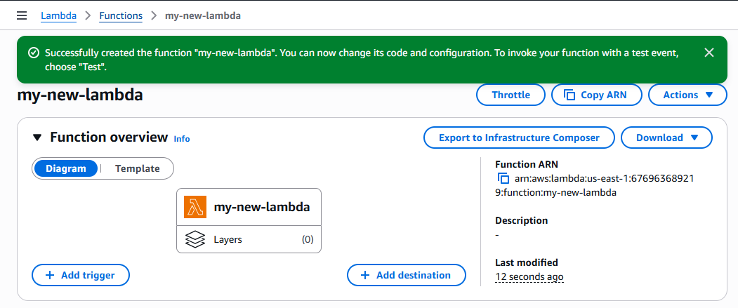
Added a previously created s3 bucket to lambda:
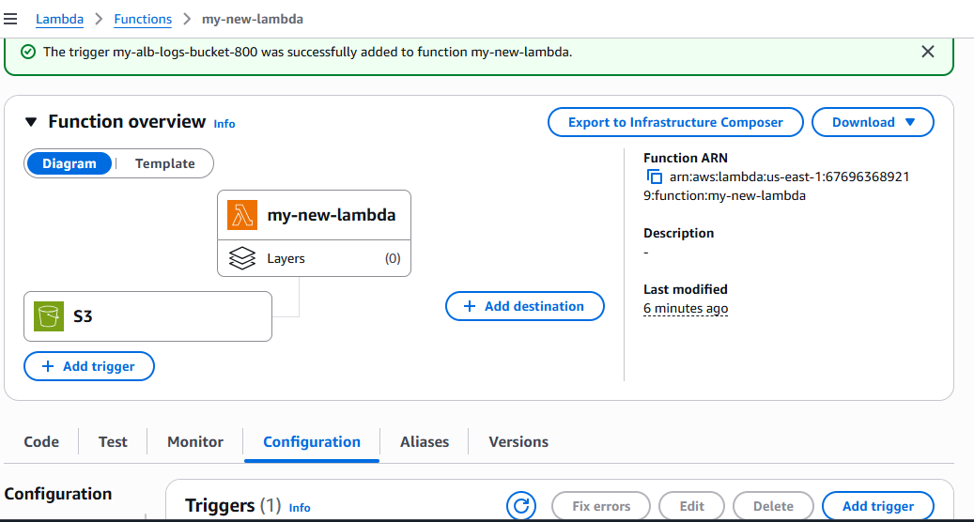
Made some changes in the deployed python code section and then deployed it as well.
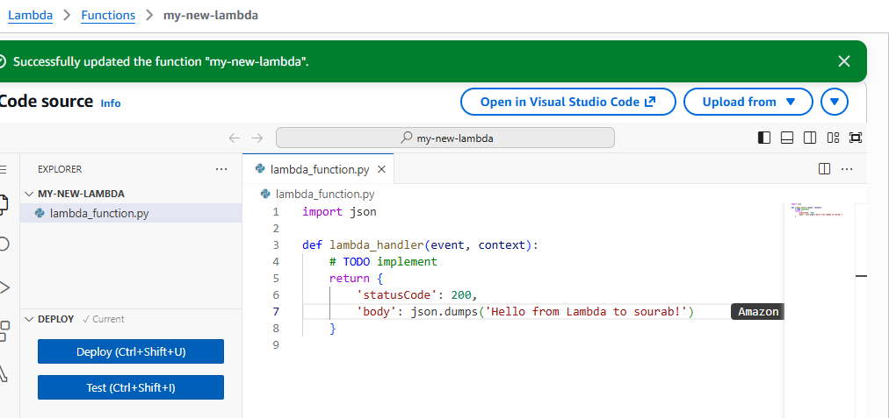
Created a new test event “my-new-event” :
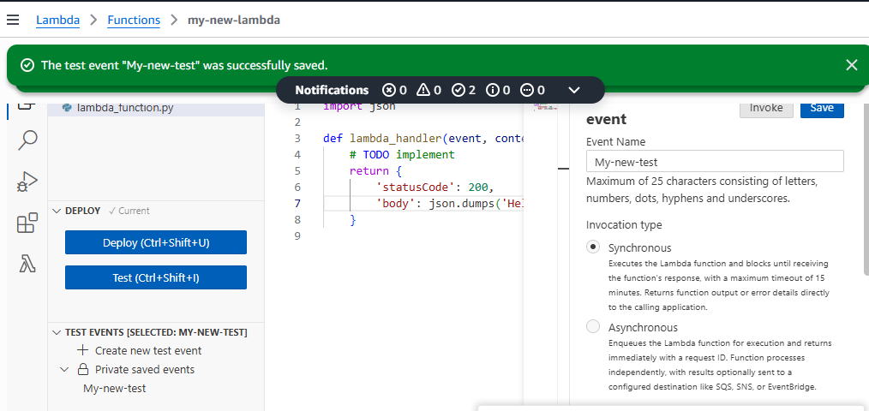
Run the deployed code as shown in the below image:
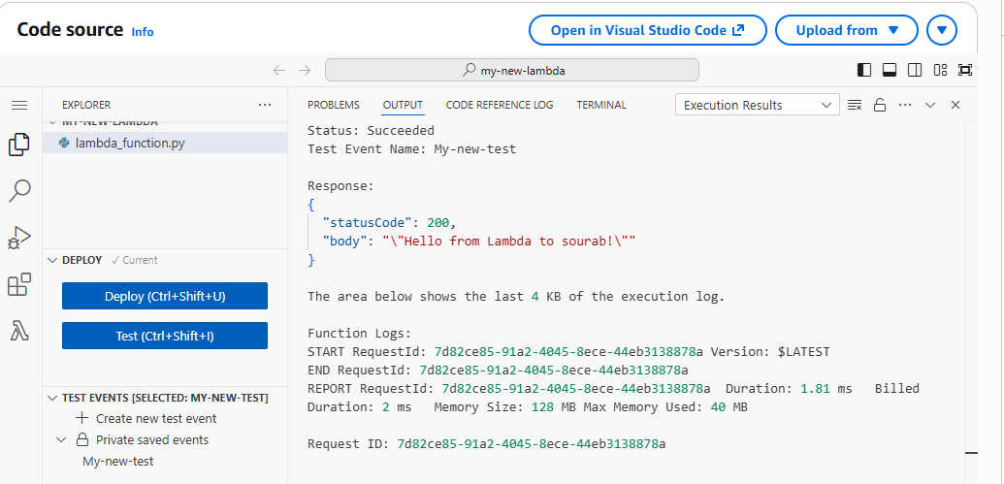
Uploaded a new file in the s3 bucket:
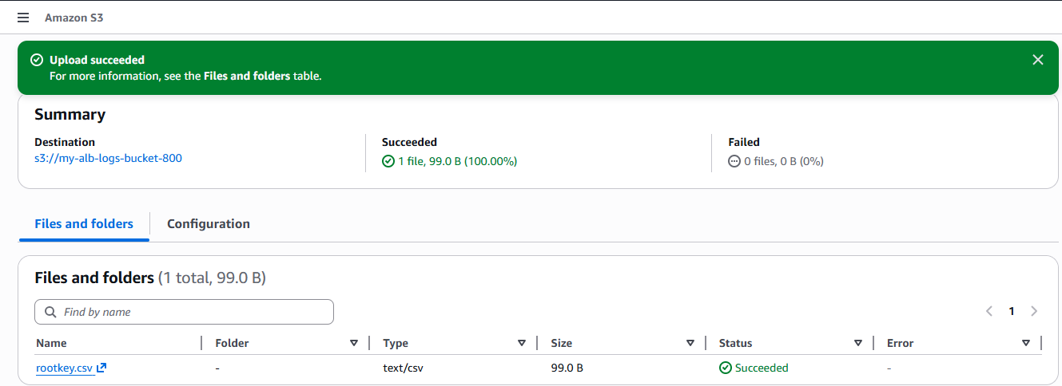
Checked logs in the cloud watch logs:
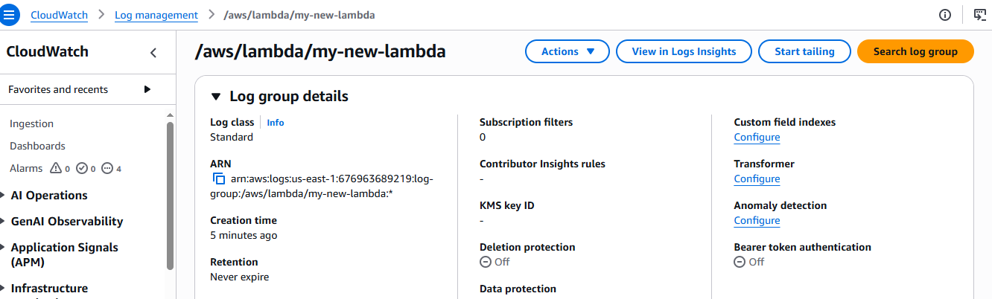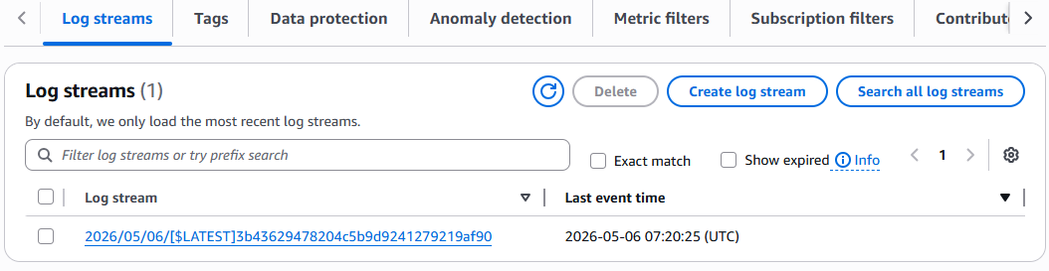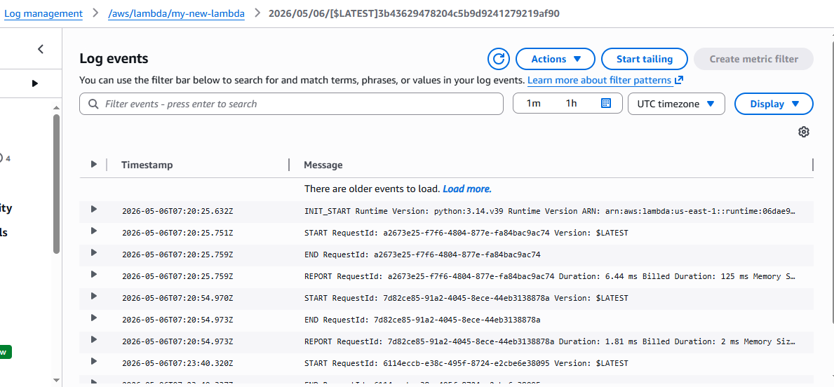
Also checked with the metrics in lambda too:
